3.1.9 Lab - DNS Lookups

Objectives
Passive reconnaissance is a method of information gathering in which the tools do not interact directly with the target device or network. In this lab, you will explore common tools used to gather information about a target through the Domain Name System (DNS).
- Use nslookup to obtain domain and IP address information.
- Use the whois command to find additional registration information.
- Compare the Output of the Nslookup and Dig tools.
- Perform Reverse DNS Lookups.

Background / Scenario
Before beginning any penetration test or other ethical hacking engagement, you need to covertly obtain as much information about the target organization as possible. There is a wealth of information that can be obtained from publicly available domain registration data. In this lab, you will investigate the output of the nslookup, whois, and dig commands.

Required Resources
- Kali VM customized for Ethical Hacker course
- Internet access

Instructions

Part 1: Use nslookup to Obtain Domain and IP Address Information.

Step 1: Log into Kali Linux and access the terminal environment.
- Log into the Kali system with the username kali and the password kali. You are presented with the Kali desktop.
- Open a terminal window by clicking on the Terminal icon located near the top of the screen.

Step 2: Investigating nslookup capabilities
Nslookup is a command line tool that is available in Linux and Windows. Its basic usage is to convert a domain name to an IP address. Nslookup has other functionality that can provide additional information.
- Access the manual pages for nslookup using the man command: man nslookup
- To review the manual pages, press the spacebar to advance the pages. When you are finished reviewing the manual pages, press q to quit and return to the command line.

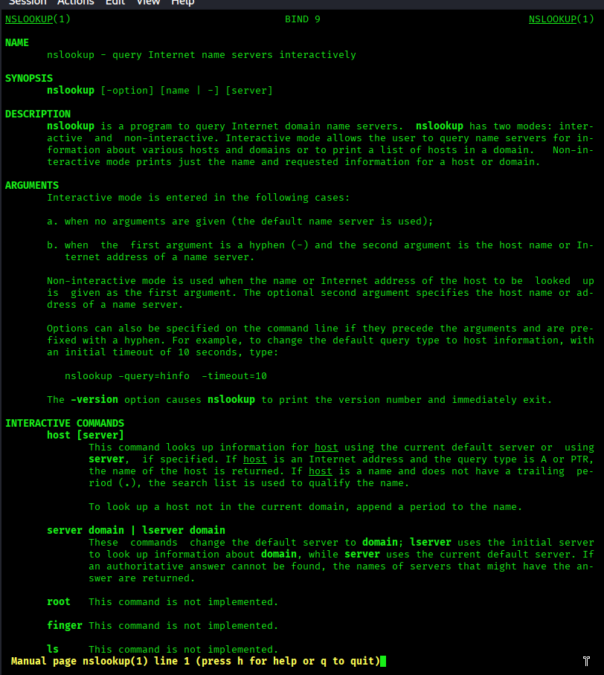
Step 3: Using the nslookup command
- Use the nslookup command with no options to enter interactive mode. To exit interactive mode at any time, type exit to return to the CLI prompt.
- The CLI prompt changes to > to indicate that you are now in interactive mode and can enter the various nslookup commands. Enter the domain name cisco.com to resolve the domain name to an IP address. By default, the nslookup command queries A and AAAA records for the target.
The output of the command will be similar to that shown. The A record contains the IPv4 address assigned to the root domain and the AAAA record contains the IPv6 address.
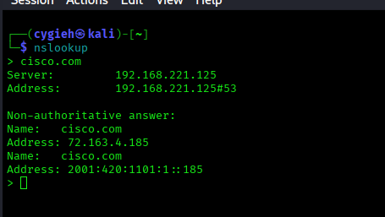
To find the domain name servers configured for cisco.com, use the set type command to change the query type to “ns” to return the name server information.
The output of the command should be similar to that shown below. The servers are listed by fully qualified domain name and are further listed as authoritative servers for both IPv4 and IPv6 addresses.
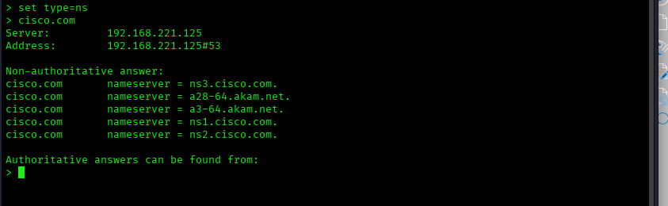
Step 4: Change the server used to perform lookups.
Occasionally it is desirable to use a different DNS server to perform lookups. This may be necessary if the local DNS server is unable to resolve an address or resolves the host name to an internal private address and you need to obtain the internet accessible address of the host.
- In this query, use the one-line nslookup command syntax to change the server to look up netacad.com. The syntax for the command is nslookup [hostname] [server IP].
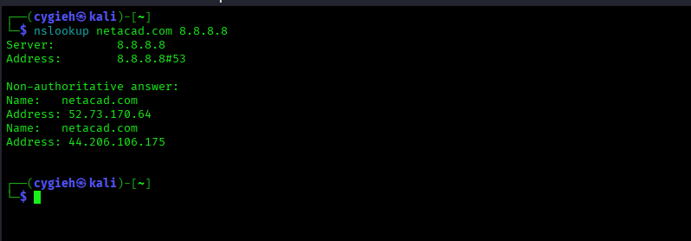
In interactive mode, you change the server using the server keyword.
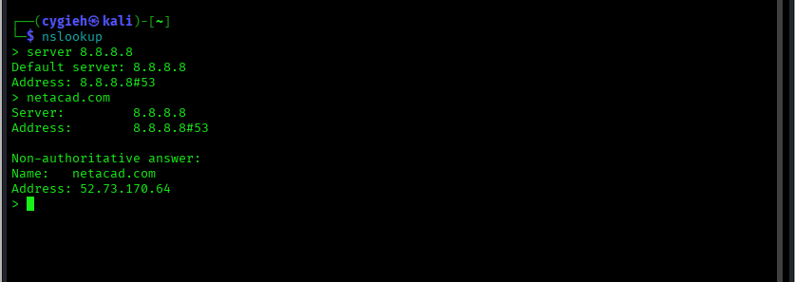
The any query type can retrieve much, or all, of the information contained in the DNS record for a host name. Often text records that can provide additional details about the domain are contained in DNS records. Using the 8.8.8.8 Google DNS server, find the DNS records for netacad.com.

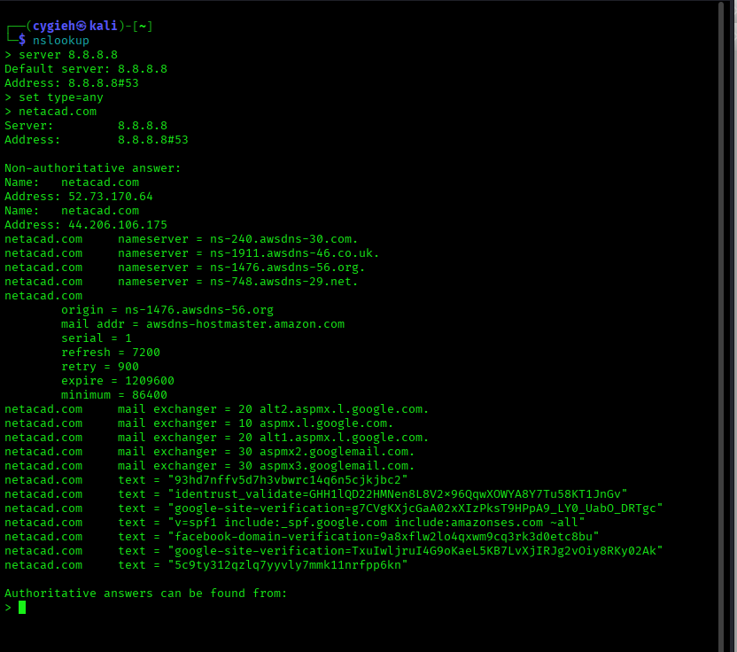
Part 2: Use the Whois function to obtain domain information
The whois tool queries domain registration information, rather than the DNS server records. It is another form of passive reconnaissance that can identify where the domain is registered, technical and administrative contact information, and physical locations. Be aware that information contained in domain registrations can be set to private and often the contact information is that of the hosting service, rather than the organization itself.

Step 1: Compare whois output for various organizations.
- The whois tool is available from the CLI prompt ion Kali Linux. Use the whois command to obtain information about cisco.com.
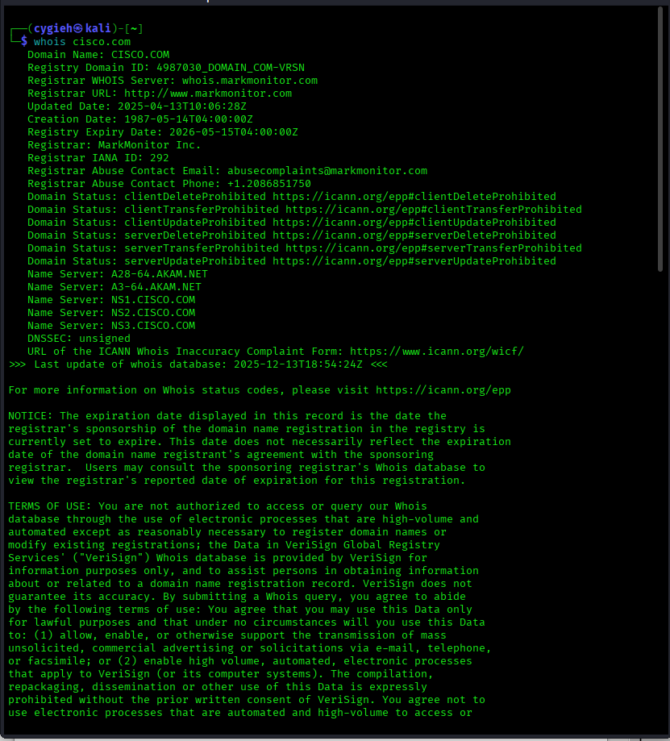
Now use the whois command to obtain information about the netacad.com domain.
Now use the whois command to obtain information about the netacad.com domain.

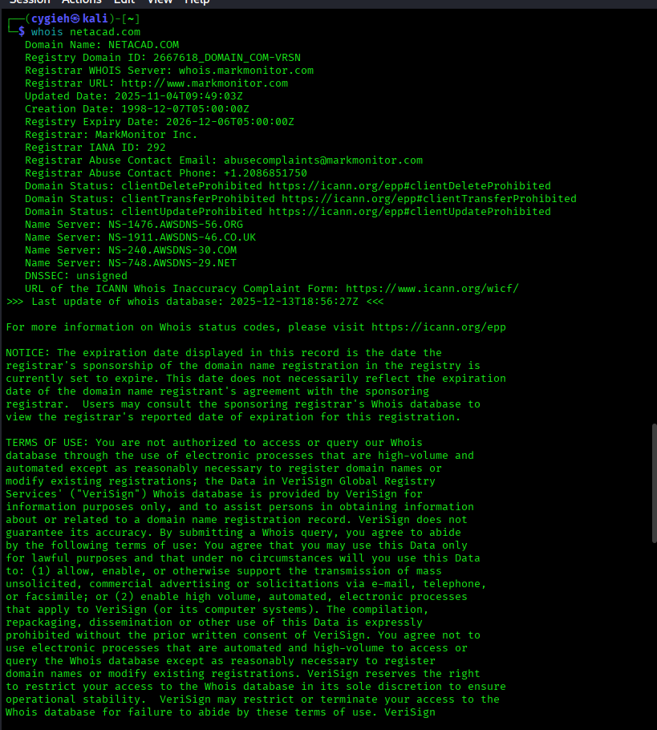
Step 2: Use whois to determine IP address registration information.
The whois tool can also be used to gather information about IP address ranges that are assigned to an organization. In the previous part of this lab, we discovered the IP addresses assigned to various domain DNS server host names. Now you can use that address information to obtain additional details about the external IP address ranges that are assigned to those organizations.
- Review the output you obtained from using nslookup to obtain the DNS server IP addresses for cisco.com. Record the IP addresses of the Cisco DNS servers.
- Use the Whois tool to find what IP address ranges are assigned to Cisco and are used on the networks hosting their DNS servers. At the time of this lab, ns1.cisco.com resolved to the IP address 72.163.5.201, however this may vary. At the prompt, enter whois 72.163.5.201.
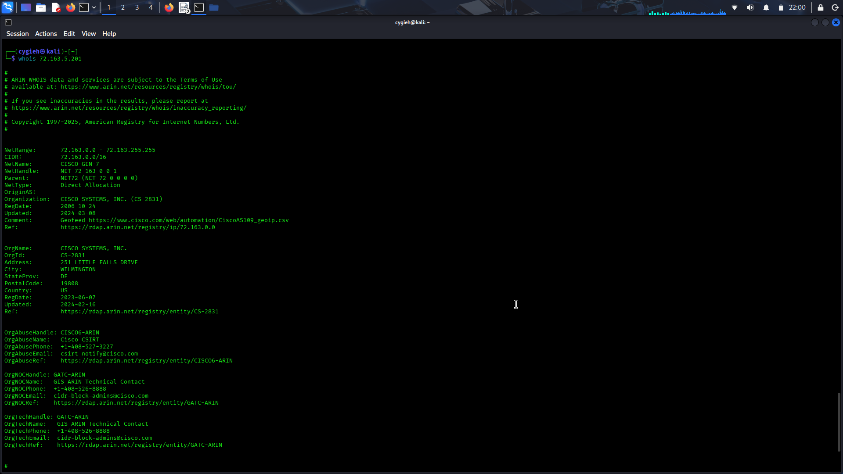
Because organizations may use the same IP networks for other externally facing servers, knowing the address ranges is valuable for determining which networks to target during a penetration test. Use the whois tool to obtain the IP address allocations for the IP networks where the other Cisco DNS servers are located.

Part 3: Compare the Output of the Nslookup and Dig Functions
Step 1: Use Linux Dig to Query for DNS servers.
- Dig is a Linux function that performs DNS queries. The format of a Dig query is similar to that of Nslookup. To resolve the hostname cisco.com to an IP address, use the syntax dig [hostname].
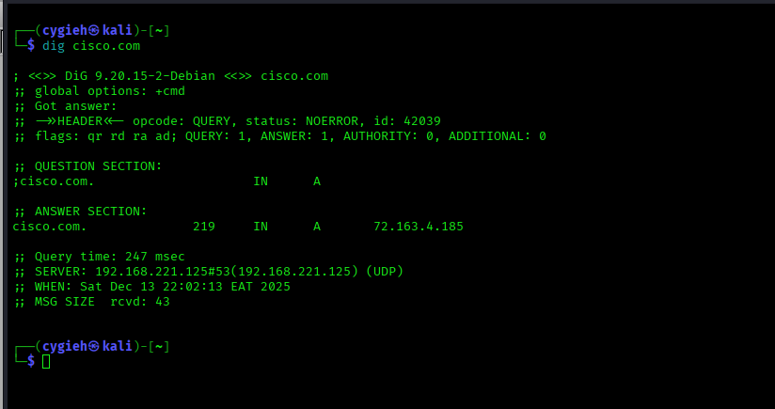
To obtain the IPv6 address of cisco.com it is necessary to add a type to the command structure. The syntax to instruct Dig to query a specific record type is dig [hostname] [record type].
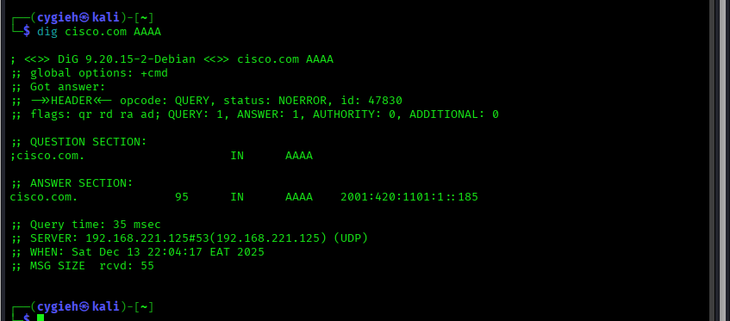
Step 2: Use Dig to Obtain Additional Information.
- In the earlier part of this lab, nslookup was used to obtain the DNS servers for cisco.com. Use the 8.8.8.8 Google DNS server to query for the DNS server records. The syntax to use a dig command to perform a query using a different DNS server is dig [hostname] @[DNS server IP] [type]. At the prompt, enter dig cisco.com 8.8.8.8 ns.
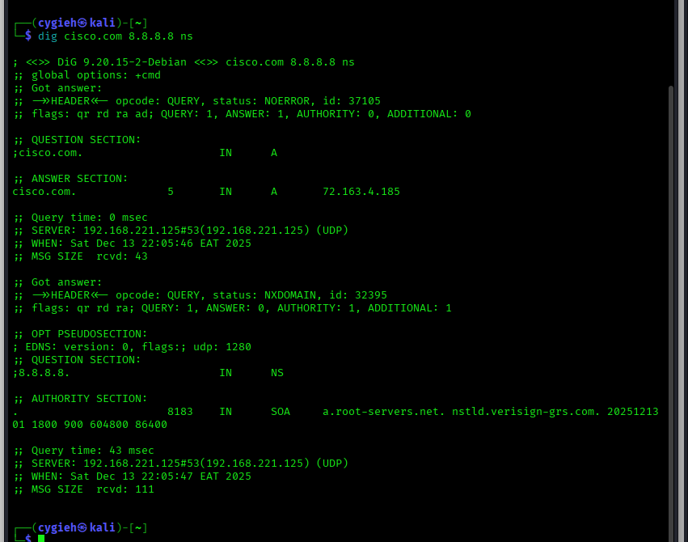
Part 4: Perform Reverse DNS Lookups
Step 1: Use Dig to Perform rDNS Lookups
Now that you can perform DNS lookups and use Whois to determine IP address ranges, use Dig to find additional host names. Reverse DNS (rDNS) lookups use the IP address to query for the host names of the services that resolve to that address.
- Enter the dig command using the -x option to retrieve the hostname and record type of the ns1.cisco.com DNS server (72.163.5.201).
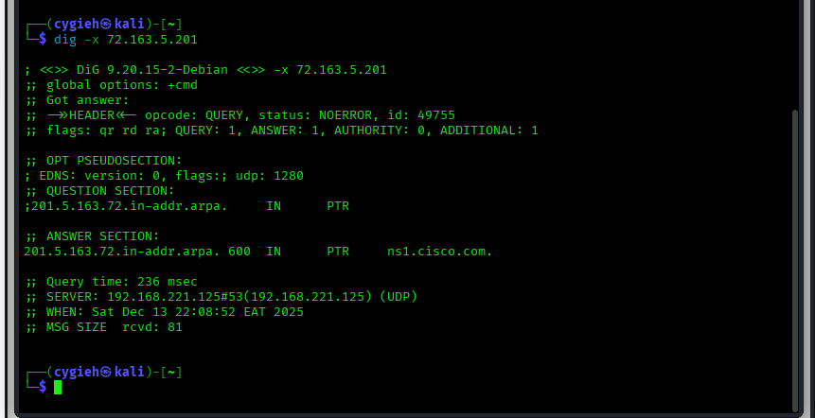
Use the dig -x command to query for another IP address in the same subnet.
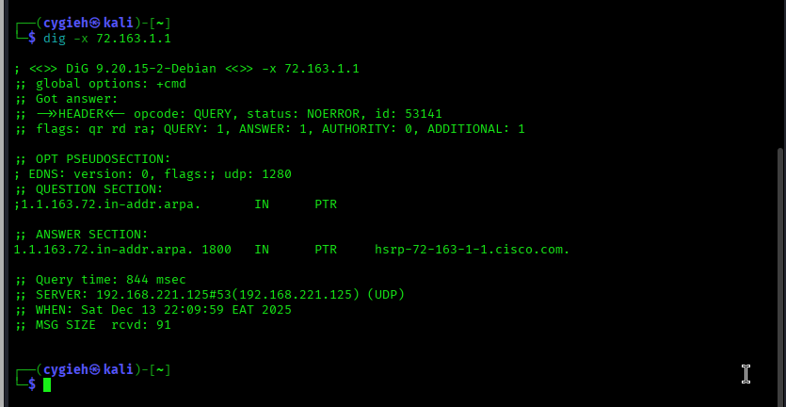
Step 2: Use the Host Utility to Perform rDNS Lookups
The Host utility is a function in Linux that performs lookups to convert IP addresses to host names. Use this utility to find another host on the 72.163.0.0/16 network.
- The syntax of the host command is host [ip address or hostname]

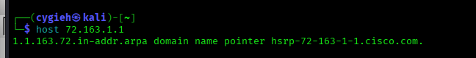
Host can also be used to perform a quick IP address lookup for a known hostname.
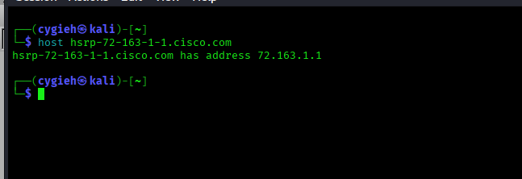
URLs often contain aliases for the host name of the server hosting the website. The output of the host command can list the servers that respond to that URL.
The information about aliases is useful when trying to determine where the actual website or service is located.

Step 3: Use nslookup to Perform rDNS Lookups
Nslookup is used primarily to perform IP address lookups for known host names. It can also be used to perform rDNS lookups to return a host name assigned to a known IP address.
Use Nslookup to find hostnames associated with an IP address.
In non-interactive mode the syntax to do an rDNS query is nslookup [ip address].
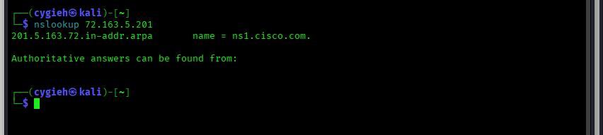
To use interactive mode, enter nslookup with no options. At the > prompt, enter the target IP address.
